Screenshots for how a ui is created and its properties
- Created through external embeded html form
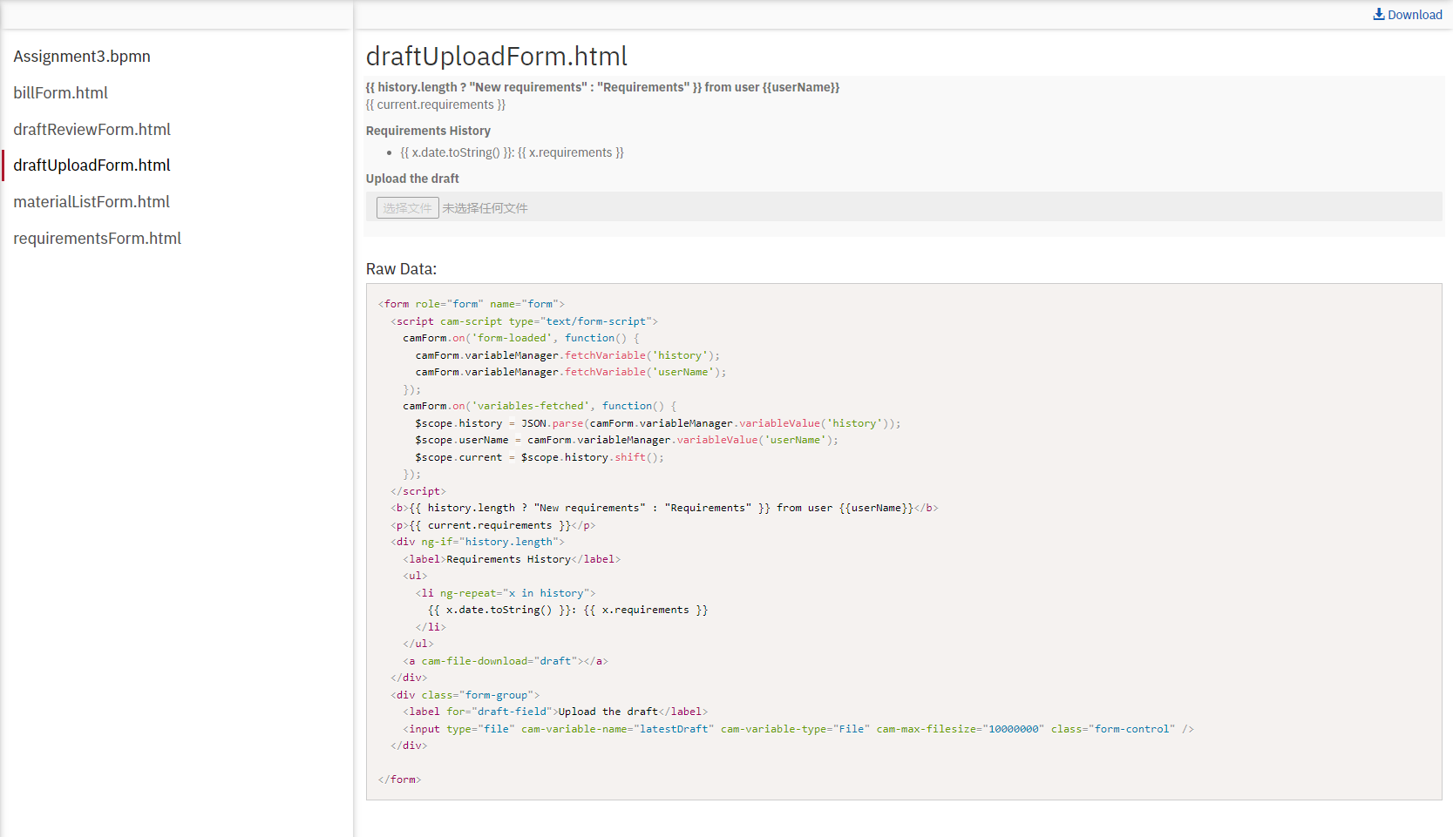

- Code example: bind properties through cam-variable-name attribute or JS & Angular code
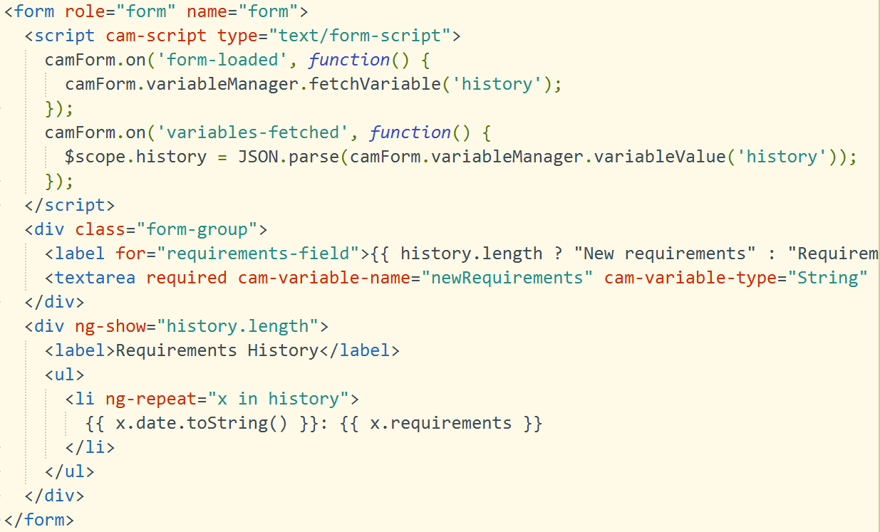

Screenshots for how variables are passed
- Inline script to declare variables when necessary
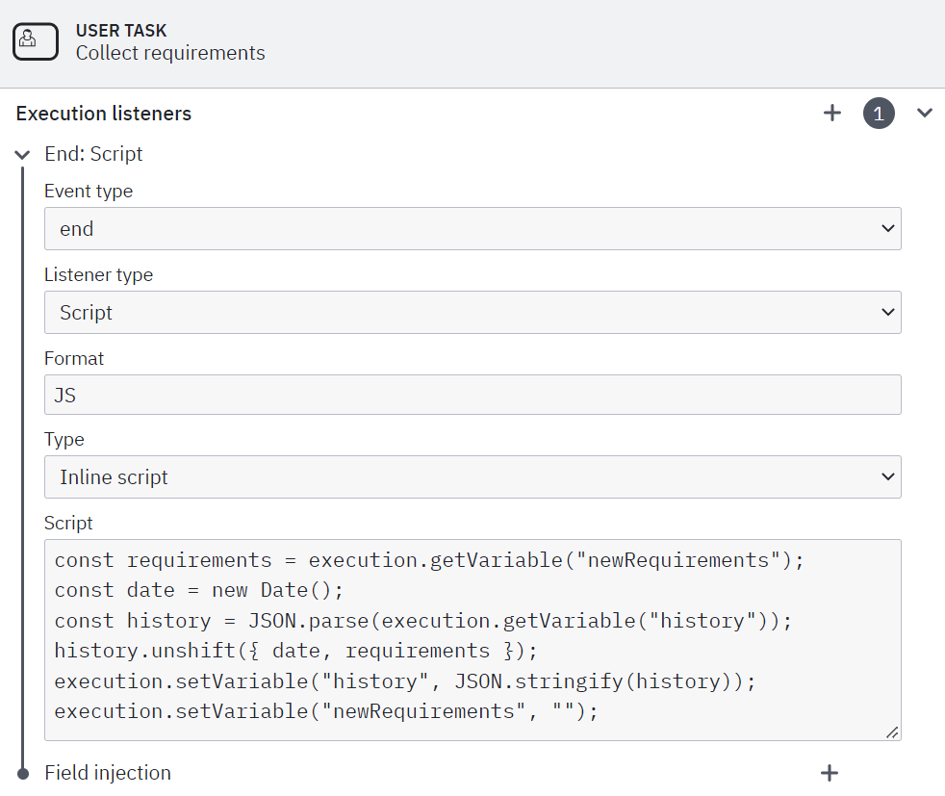

- JS external script for service tasks
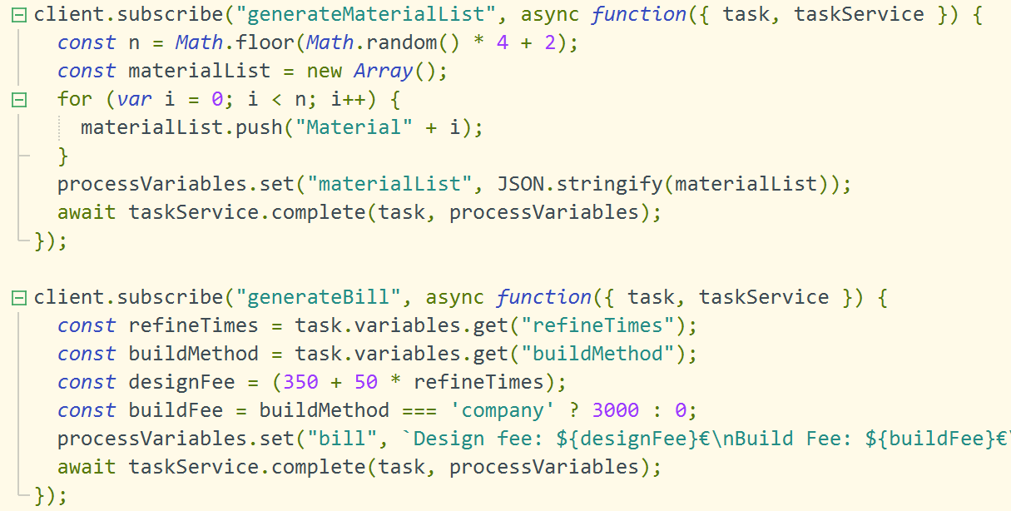

Screenshots for each user task

Collect requirements
For the first time
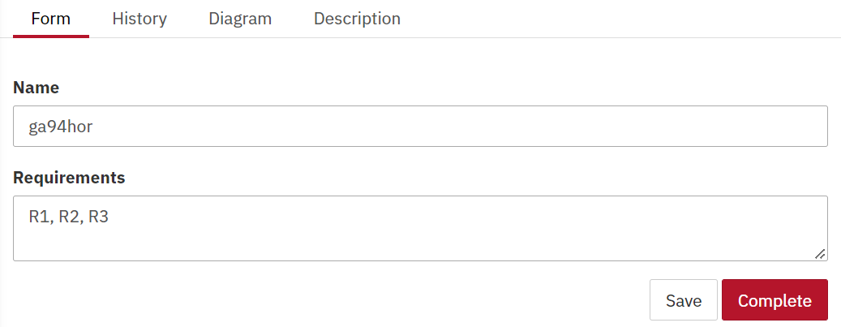
Add additional requirements
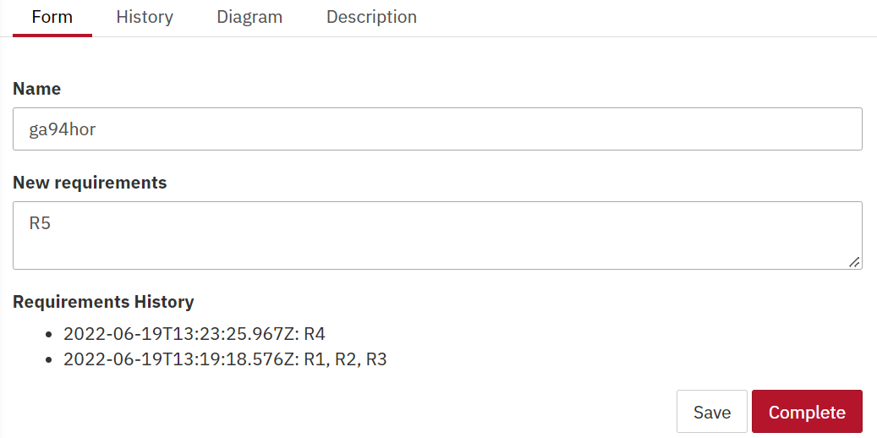

Upload the draft
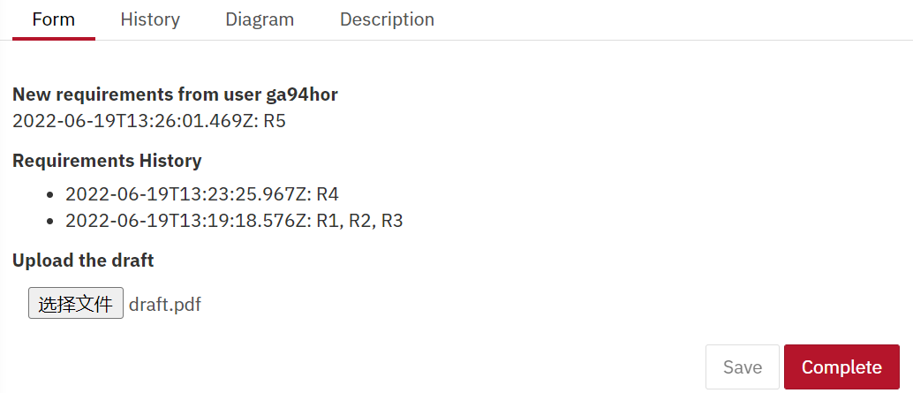

Review the draft
if not satisfied with the draft
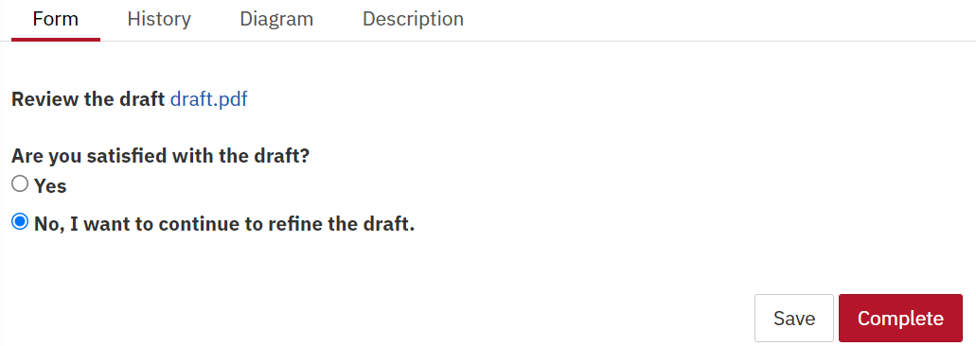
if satisfied with the draft, then make decision about the build method
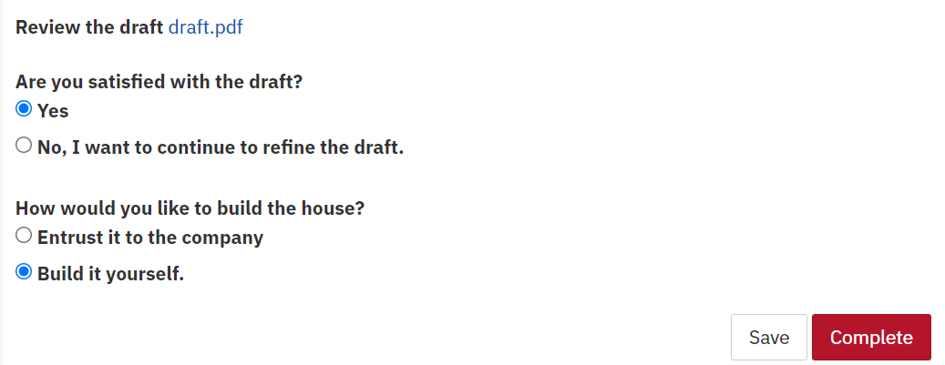

Buy materials
if the user want to build the house by himself
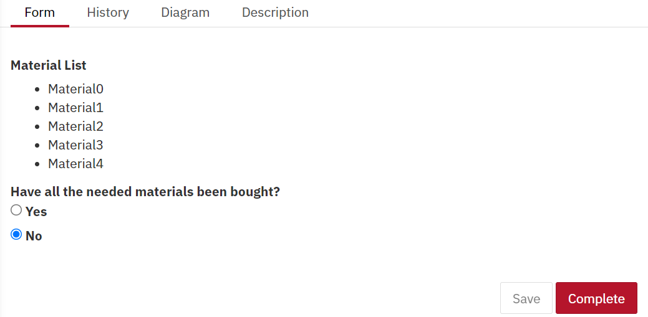

Pay the bill
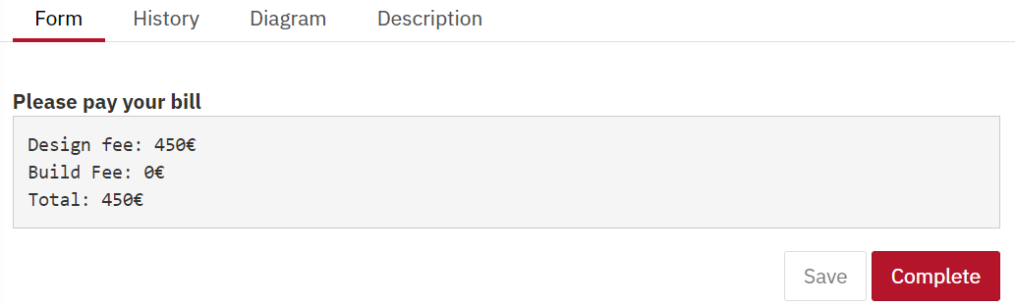

Screenshot of the running process
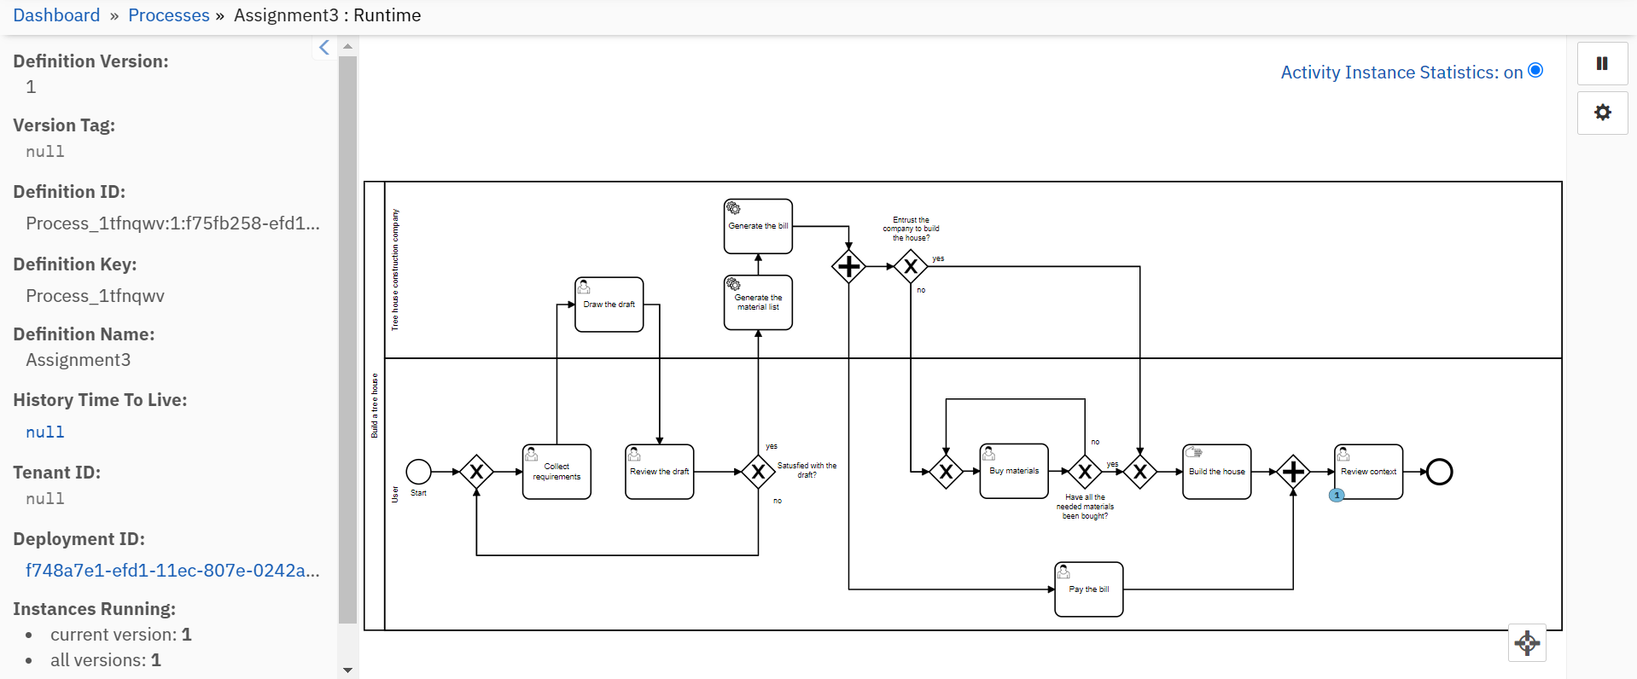

Screenshot of the last task displaying the context
